

**Topic: Search Filters**

When searching for a document in **theSource** you can use the **Search Filters** on the sidebar of the Search Results page to narrow down your results, when needed.

We have the following categories for **Search Filters** (also called **Data Facets**). Select one or more of these to display documents tagged for those categories:

* Document Type
* Subject
* Process
* Training
* Client
* Segment
* System

Here is an example where we searched for ‘Prescriptions’. With a common word like that, it’s no surprise we found over 2000 documents! We could change our keywords to try being more specific, or look at the Search Filters to try to narrow down our current search results.

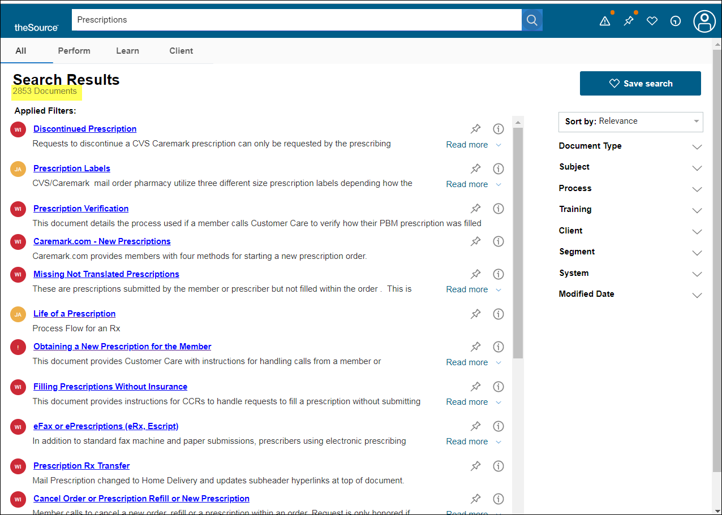

For example, if we are looking for something related to prescription ‘Claims’ there is a Search Filter listed for that. Click the check box and now we have narrowed our results down to 15 documents!

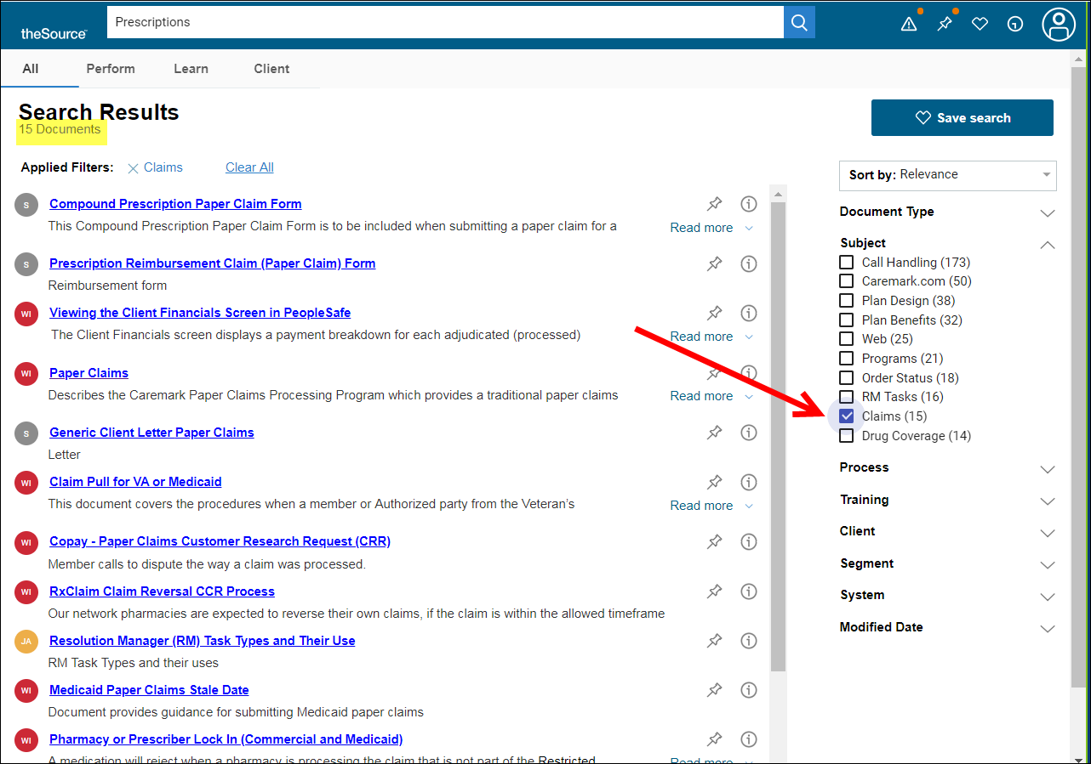

 Your next challenge on the quest to becoming a Certified theSource Wizard is to use the Search Filters the next time you have trouble finding a document in theSource.

Not to Be Reproduced or Disclosed to Others without Prior Written Approval

**ELECTRONIC DATA = OFFICIAL VERSION / PAPER COPY = INFORMATIONAL ONLY**